Software Requirements Specification
For

EventHub

Table of Contents
1. Introduction 3
1.1 Purpose 3
1.2 Document Conventions 3
1.3 Intended Audience and Reading Suggestions 3
1.4 Project Scope 3
1.5 References 3
2. Overall Description 4
2.1 Product Perspective 4
2.2 Product Features 4
2.3 User Classes and Characteristics 5
2.4 Operating Environment 5
2.5 Design and Implementation Constraints 5
2.6 User Documentation 5
2.7 Assumptions and Dependencies 5
3. System Features 6
3.1 Secure Login 6
3.2 SignUp 6
3.3 StartUp Screen 6
3.4 Events 7
3.5 Categories 7
3.6 Search 7
3.7 Notifications 8
3.8 Create Event 8
3.9 Event Detail 9
4. External Interface Requirements 9
4.1 User Interfaces 9
4.2 Hardware Interfaces 9
4.3 Software Interfaces 10
4.4 Communications Interfaces 10
5. Other Nonfunctional Requirements 10
5.1 Performance Requirements 10
5.2 Security Requirements 10
6. Optional Requirements 10

Introduction

Purpose
The SRS is describing the development of a EventHub. A program which will serve as a centralized event management platform.

Document Conventions
The SRS uses, wherever possible, the standard conventions of the Software Development Life Cycle. The construction of graphical representation will use the standard UML format as the industry standard.

Intended Audience and Reading Suggestions
This SRS will be used by the team members of Technik to assist in the development of EventHub. Various interested parties, who will be observing and consulting in the development, will have access to the most current version of the SRS. Those parties, at present, include supervising lecturer and assistant.

The SRS contains a detailed description of the software development and required components with suggested feature inclusions. Detailed interface diagrams are included to show how the software will interact with the user, hardware, other software and methods of communication.

The development team should begin with the detailed description in Section 2, and then proceed to the interface requirements in Section 4 to understand the implementation requirements. Other interested partings should use the diagrams represented in Appendix B to help visualize the development process detailed in the various sections in the SRS.

Project Scope
EventHub will enable users to follow events of their interests, get vital information about these events such as location, time, etc, subscribe to numerous categories, get notifications on upcoming events as well as create events of their own.

References
The references used with the development of this SRS and the software are noted below:
Android Developer resources,
Software Engineering, A Practitioners Approach by Roger Presmen,
sce2.umkc.edu.

Overall Description

Product Perspective
The Eventhub application is a standalone application. This first version of the application will feature on only the android platform. The app depends on a remote MySql database that holds persistent data pertaining to the app. Eventhub will be used only to display information entered by users during the creation of events. The user will have the ability to structure his feed to suit his interests.

Product Features
There will be seven main features associated with EventHub– Signup, StartUp, OptionsMenu, Login, Create Event, Notifications, Search and Home Screen with All events, Events by Category, Events by Date, My Events and Event Detail

Login – This is a user’s secure login. The login will allow the user to access information related to all events or specific events of his/her choosing.

Signup – The signup feature allows a user to create an account by providing relevant personal information to enable the app identify the user and personalize the user’s experience.

StartUp – The startup screen allows the user to subscribe to various categories of events and thus personalize the user experience.

OptionsMenuButton – The optionsmenu button, which is found on the right of the actionbar, opens a menu which provided the user access to certain options and utilities from anywhere in the app.
This options menu will allow the user to logout, access the settings of the app etc.

Home Screen - Once the user is logged in or signs up, event data is requested from the backend which is displayed on the home page in the form of “feed” which will update itself as the page is reloaded. The home screen shows 4 tabs labeled with the following titles from left to right: Events, Categories,Search, Notifications. It also has a “plus” floating button.

Events – This is first tab on the toolbar. It shows a list of events in the form of a timeline which can be filtered based on a drop down selector menu found below the tab bar. This drop down shows the following: All Events, My Events, Interested, Going and Subscriptions.

Categories – This appears as the second tab on the home screen. This will show all the categories of events our app has and touching on any of them opens a list of events based on the selected category.

Search – This appears as the third icon on the home screen. This tab presents the user with a search bar which brings a search engine feature to the app.

Notification – This is the last tab on the home screen. This section shows a list of notifications pertaining to events the user has liked and is attending such as the number of days left.

Floating Action Button – This button persists through all 4 tabs and opens a page where a user can create his own event.

User Classes and Characteristics
EventHub would have primarily two kinds of users. Creators and Users.

The creators would be primarily people who just create events and have no interest in patronizing other events. An example would be organisations.

Users would be people who patronize events. This category is sub-divided into two groups, these being only users and a create/user group. The create/user group mostly create and patronize events.

See Appendix B for User Interaction Diagrams.

Operating Environment
EventHub is an android mobile application that has network access to allow it to connect to the online server database. This connection allows the app to load events from the database.

Design and Implementation Constraints
The following is an initial list of constraints that must be considered during the development process. More constraints than those listed may arise as security and corporate policies become available and application is required.

- Internet speed and connection would affect the load speed of events.
- Android version of device would affect implementation of some features.
- GUI interfaces must convert responses from XML format to display on the handheld device screen.

User Documentation
EventHub is designed to be simple and easy to understand and thus requires no user manual or tutorial.

Assumptions and Dependencies
Effective operation of EventHub would depend on the following conditions being met.
- The android device has internet access.
- Google Play Services installed and up to date.
- Permission to access device storage, camera and google services given.
- The android device has an android version of 5.0 or higher.

System Features
The following are detailed descriptions of the seven features listed in Section 2.3. As the design component of development cycle progresses, additional details for these features may be added to this SRS.

Secure Login
3.1.1 Description and Priority
High Priority – This interface will allow the user to gain access to the events on the EventHub database.
3.1.2 Stimulus/Response Sequences
The physician/pharmacist will enter his/her username and password in the appropriate fields then hit a login button.
3.1.3 Functional Requirements
REQ-1: The user must have a valid user login to access the system.
REQ-2: A failed login will alert the user.

SignUp
3.2.1 Description and Priority
High Priority – This will allow a user to create an account to enable the user view events.
3.2.2 Stimulus/Response Sequences
The user will input relevant personal information needed in the appropriate fields.
Pressing the signup button will send the information to the EventHub database and create a unique account for the user.
Tapping the signup button will create an account and send the user to the log in screen.
3.2.3 Functional Requirements
REQ-1: All information entered is valid and unique.
REQ-2: An empty field would alert the user.
REQ-3: A failed signup will alert the user.

StartUp Screen
3.3.1 Description and Priority
High Priority – This is the initial view after a user’s first signup.
3.3.2 Stimulus/Response Sequences
The startup screen shows the list of categories of events.
The user can select the categories he/she is interested in and thus subscribe to them.
Tapping the subscribe button sends you to the home screen.
3.3.3 Functional Requirements
REQ-1: The font will be large enough for easy reading.
REQ-2: Icons will clearly illustrate the feature it represents.

Events
3.4.1 Description and Priority
High Priority – This is the default view of the Home Screen and is the first icon in the
3.4.2 Stimulus/Response Sequences
Shows all events in the database in a list scroll view regardless of category.
Shows a summary of the event information; flyer, name and date.
Selecting an event opens an Event Detail page showing all information related to the event.
3.4.3 Functional Requirements
REQ-1: The font will be large enough for easy reading.
REQ-2: Icons and Pictures will clearly illustrate the feature it represents.
REQ-3 Event feed should list events based on time of creation i.e most recent events appear on top.

Categories
3.5.1 Description and Priority
High Priority – This is the second tab on the home screen and shows events filtered by category.
3.5.2 Stimulus/Response Sequences
A drop-down list will allow the user to filter events by category and display them.
Shows a summary of the event information; flyer, name and date.
Selecting an event opens an Event Detail page showing all information related to the event.
3.5.3 Functional Requirements
REQ-1: The font will be large enough for easy reading.
REQ-2: Icons and Pictures will clearly illustrate the feature it represents.

Search
3.6.1 Description and Priority
High Priority – This is the third tab of the home screen.
3.6.2 Stimulus/Response Sequences
A search bar allows the user to search the database for an event and filter the events by the query made.
Shows a summary of the event information; flyer, name and date.
Selecting an event opens an Event Detail page showing all information related to the event.
3.6.3 Functional Requirements
REQ-1: Each query is a valid query.
REQ-2: The font will be large enough for easy reading.
REQ-3: Icons and Pictures will clearly illustrate the feature it represents.

Notifications
3.7.1 Description and Priority
High Priority – This is the fourth tab of the Home Screen and shows reminders and notifications about the events you have shown interest – either by liking or attending - in.
3.7.2 Stimulus/Response Sequences
Shows a reminder or notification of the event.
Shows a summary of the notification -be it reminder or change.
Selecting an event opens an Event Detail page showing all information related to the event.
3.7.3 Functional Requirements
REQ-1: The font will be large enough for easy reading.
REQ-2: Icons and Pictures will clearly illustrate the feature it represents.

Create Event
3.7.1 Description and Priority
High Priority – This is the floating action button that persists in all screens.
3.7.2 Stimulus/Response Sequences
The upload image icon opens the user’s photo gallery or camera based on what he chooses to enable him upload a picture as the flyer.
Touching all forms open keyboard to allow user input.
Selecting event location opens 2-dimensional google map to let the user select the event location
Date and Time open pickers for each for user input.

3.7.3 Functional Requirements
REQ-1: A description and time/date of each prescription that has been ordered or given is displayed starting with most recent.
REQ-2: The map opened to allow the user to search the event by name or by using a picker.

Event Detail
3.7.1 Description and priority
This section give detailed information about the selected event such as a the location, a description of the event and contact information aside the event date time, flyer and name which are displayed in other parts of the app.
3.7.2 Stimulus/Response Sequences
Tapping on event location opens a 2-dimensional map showing the location of the event.
Tapping on like and attend should let the user “like” and “attend” the event respepctively.
Tapping on the phone number under event Details should open the user’s phone app and allow him to call that number.
Tap event flyer to get a bigger view.

3.7.3 Functional Requirements
REQ-1: The event flyer needs to be big enough to be seen.
REQ-2 - The venue of the event should synchronize with your location using gps.
REQ-3 - The number of users attending and interested in that event should be updated
After every reload of that event detail page.

External Interface Requirements

User Interfaces
The User Interface will adhere to standard viewing protocols. In that, the look and feel will maintain high contrast and high visibility throughout the software. The background will be fairly light in color with dark colored font to enhance the contrast and visibility. Icons will make use of dark colors and be of a relation to the subject matter to which they navigate. The layout will be constrained to the size and scope of the phone’s display screen.

Sample screenshots of the user interface may be seen in Appendix A of this SRS.

Hardware Interfaces
The Eventhub will be available on the playStore for download on mobile devices running android versions 5.0 and above. Minor adjust will be made to accommodate the varying sizes of the display screens of the devices i.e tablets and phones. The app will not have support for PC.

Software Interfaces
Eventhub will interface. To obtain full benefit of the Pocket M.D. features, the existing system must run in real-time and support automatic updates of patient information pertaining to the features contained within the Pocket M.D. The Pocket M.D. will perform most reliably within systems where the entire family of Cerner Millennium products is utilized.

Communications Interfaces
The Eventhub app requires internet connection for its usage. Hence it utilizes the cellular or wireless connections of the mobile device. It wirelessly sends and receives information from the online dastabase which contains all the data pertaining to the app. The app also uses GPS for positioning of the user device on the map.

Other Nonfunctional Requirements

Performance Requirements
Eventhub’s reliability will only be constrained by the device’s internet connectivity and the database server access.

Security Requirements
Users will be authenticated to enable access to EventHub.

Optional Requirements
An IOS version may be developed in a future release. This will widen the user base of EventHub.
Appendix A: User Interface Sample Images

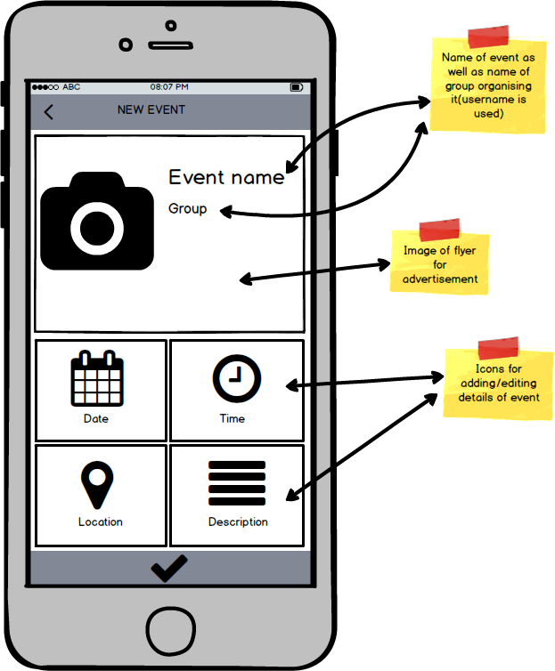
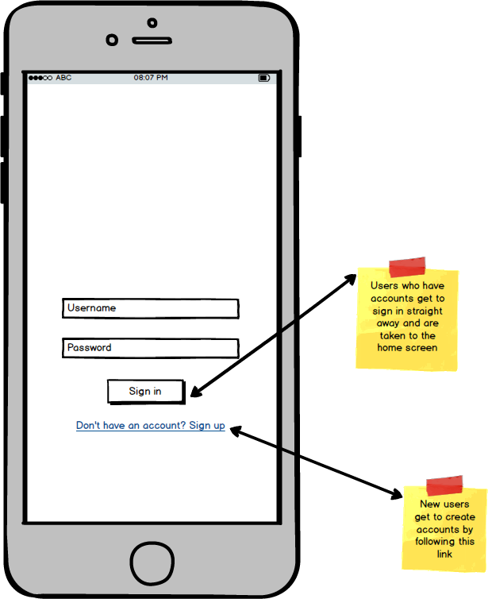
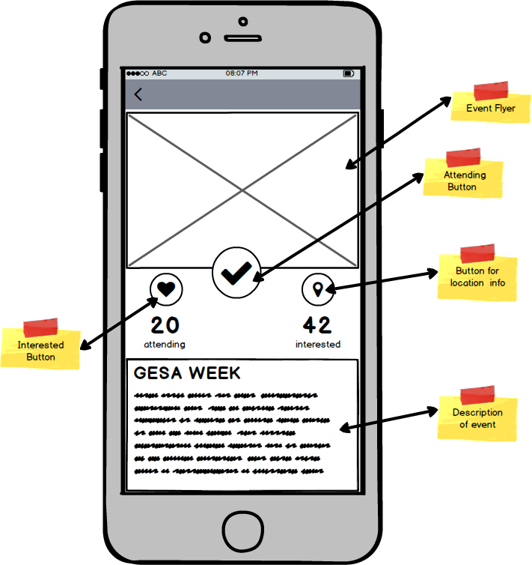

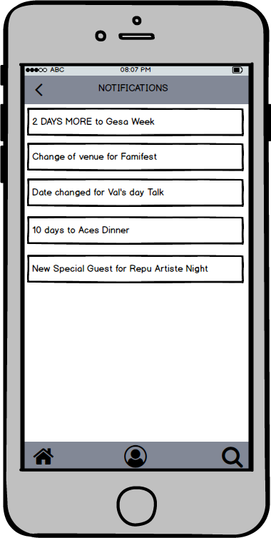
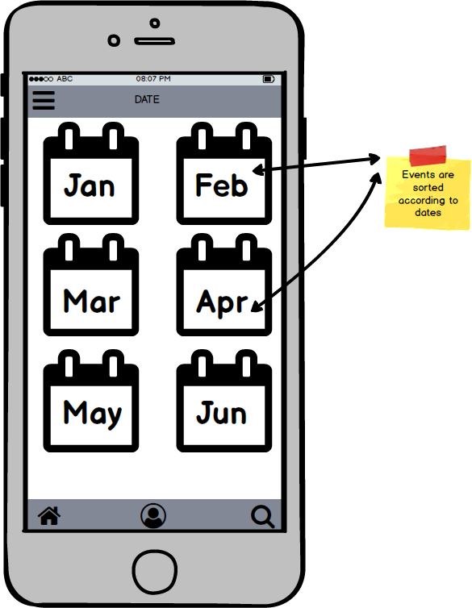
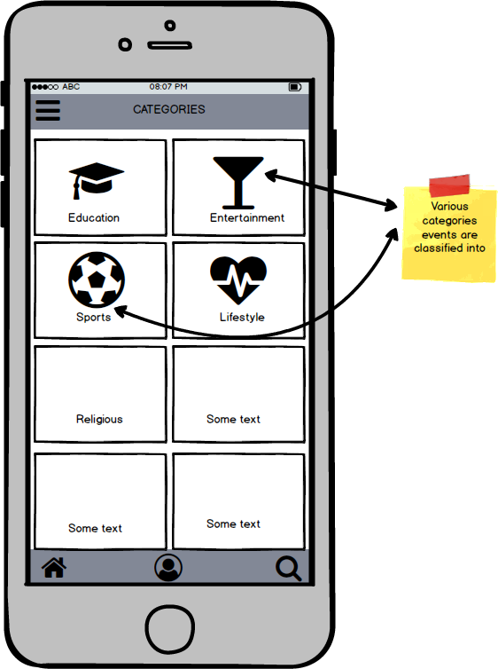

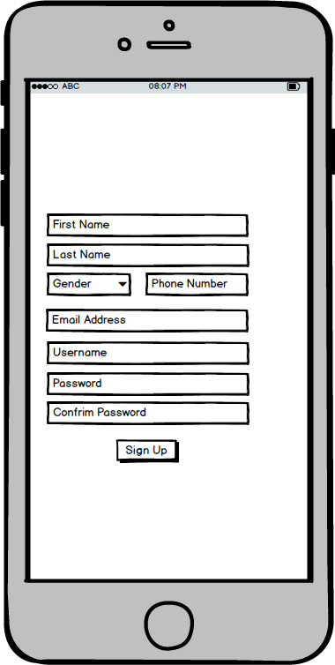
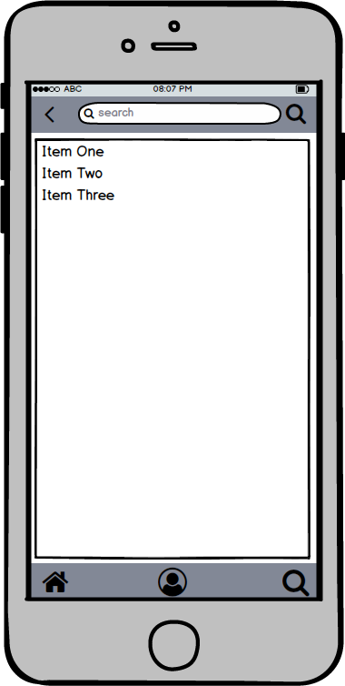
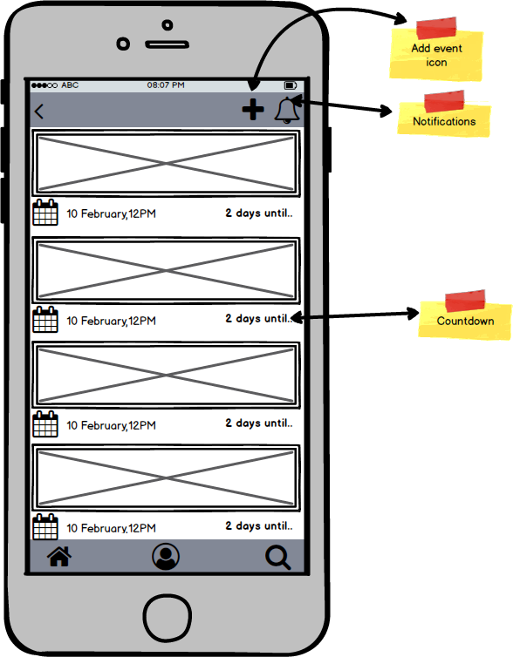
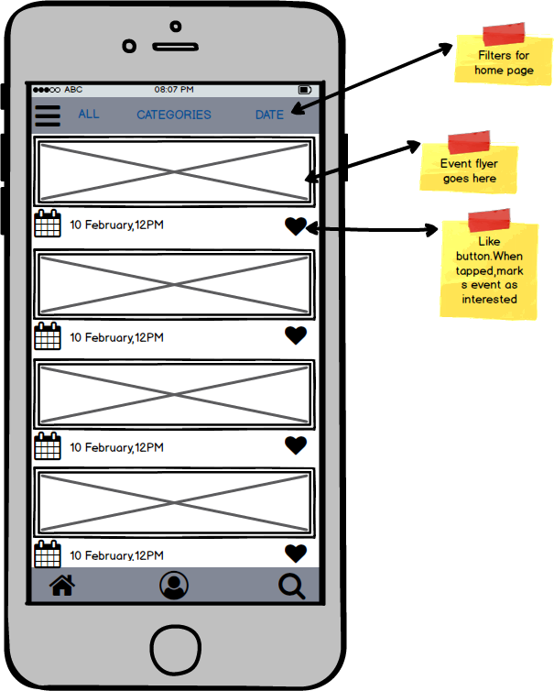
Appendix B: Analysis Models

User Interaction Diagrams

